Roy Wiseman

Roy Wiseman retired from the Region of Peel in 2011, after a long career as Director, Information and Technology and Services and as the Region’s first Chief Information Officer (CIO).
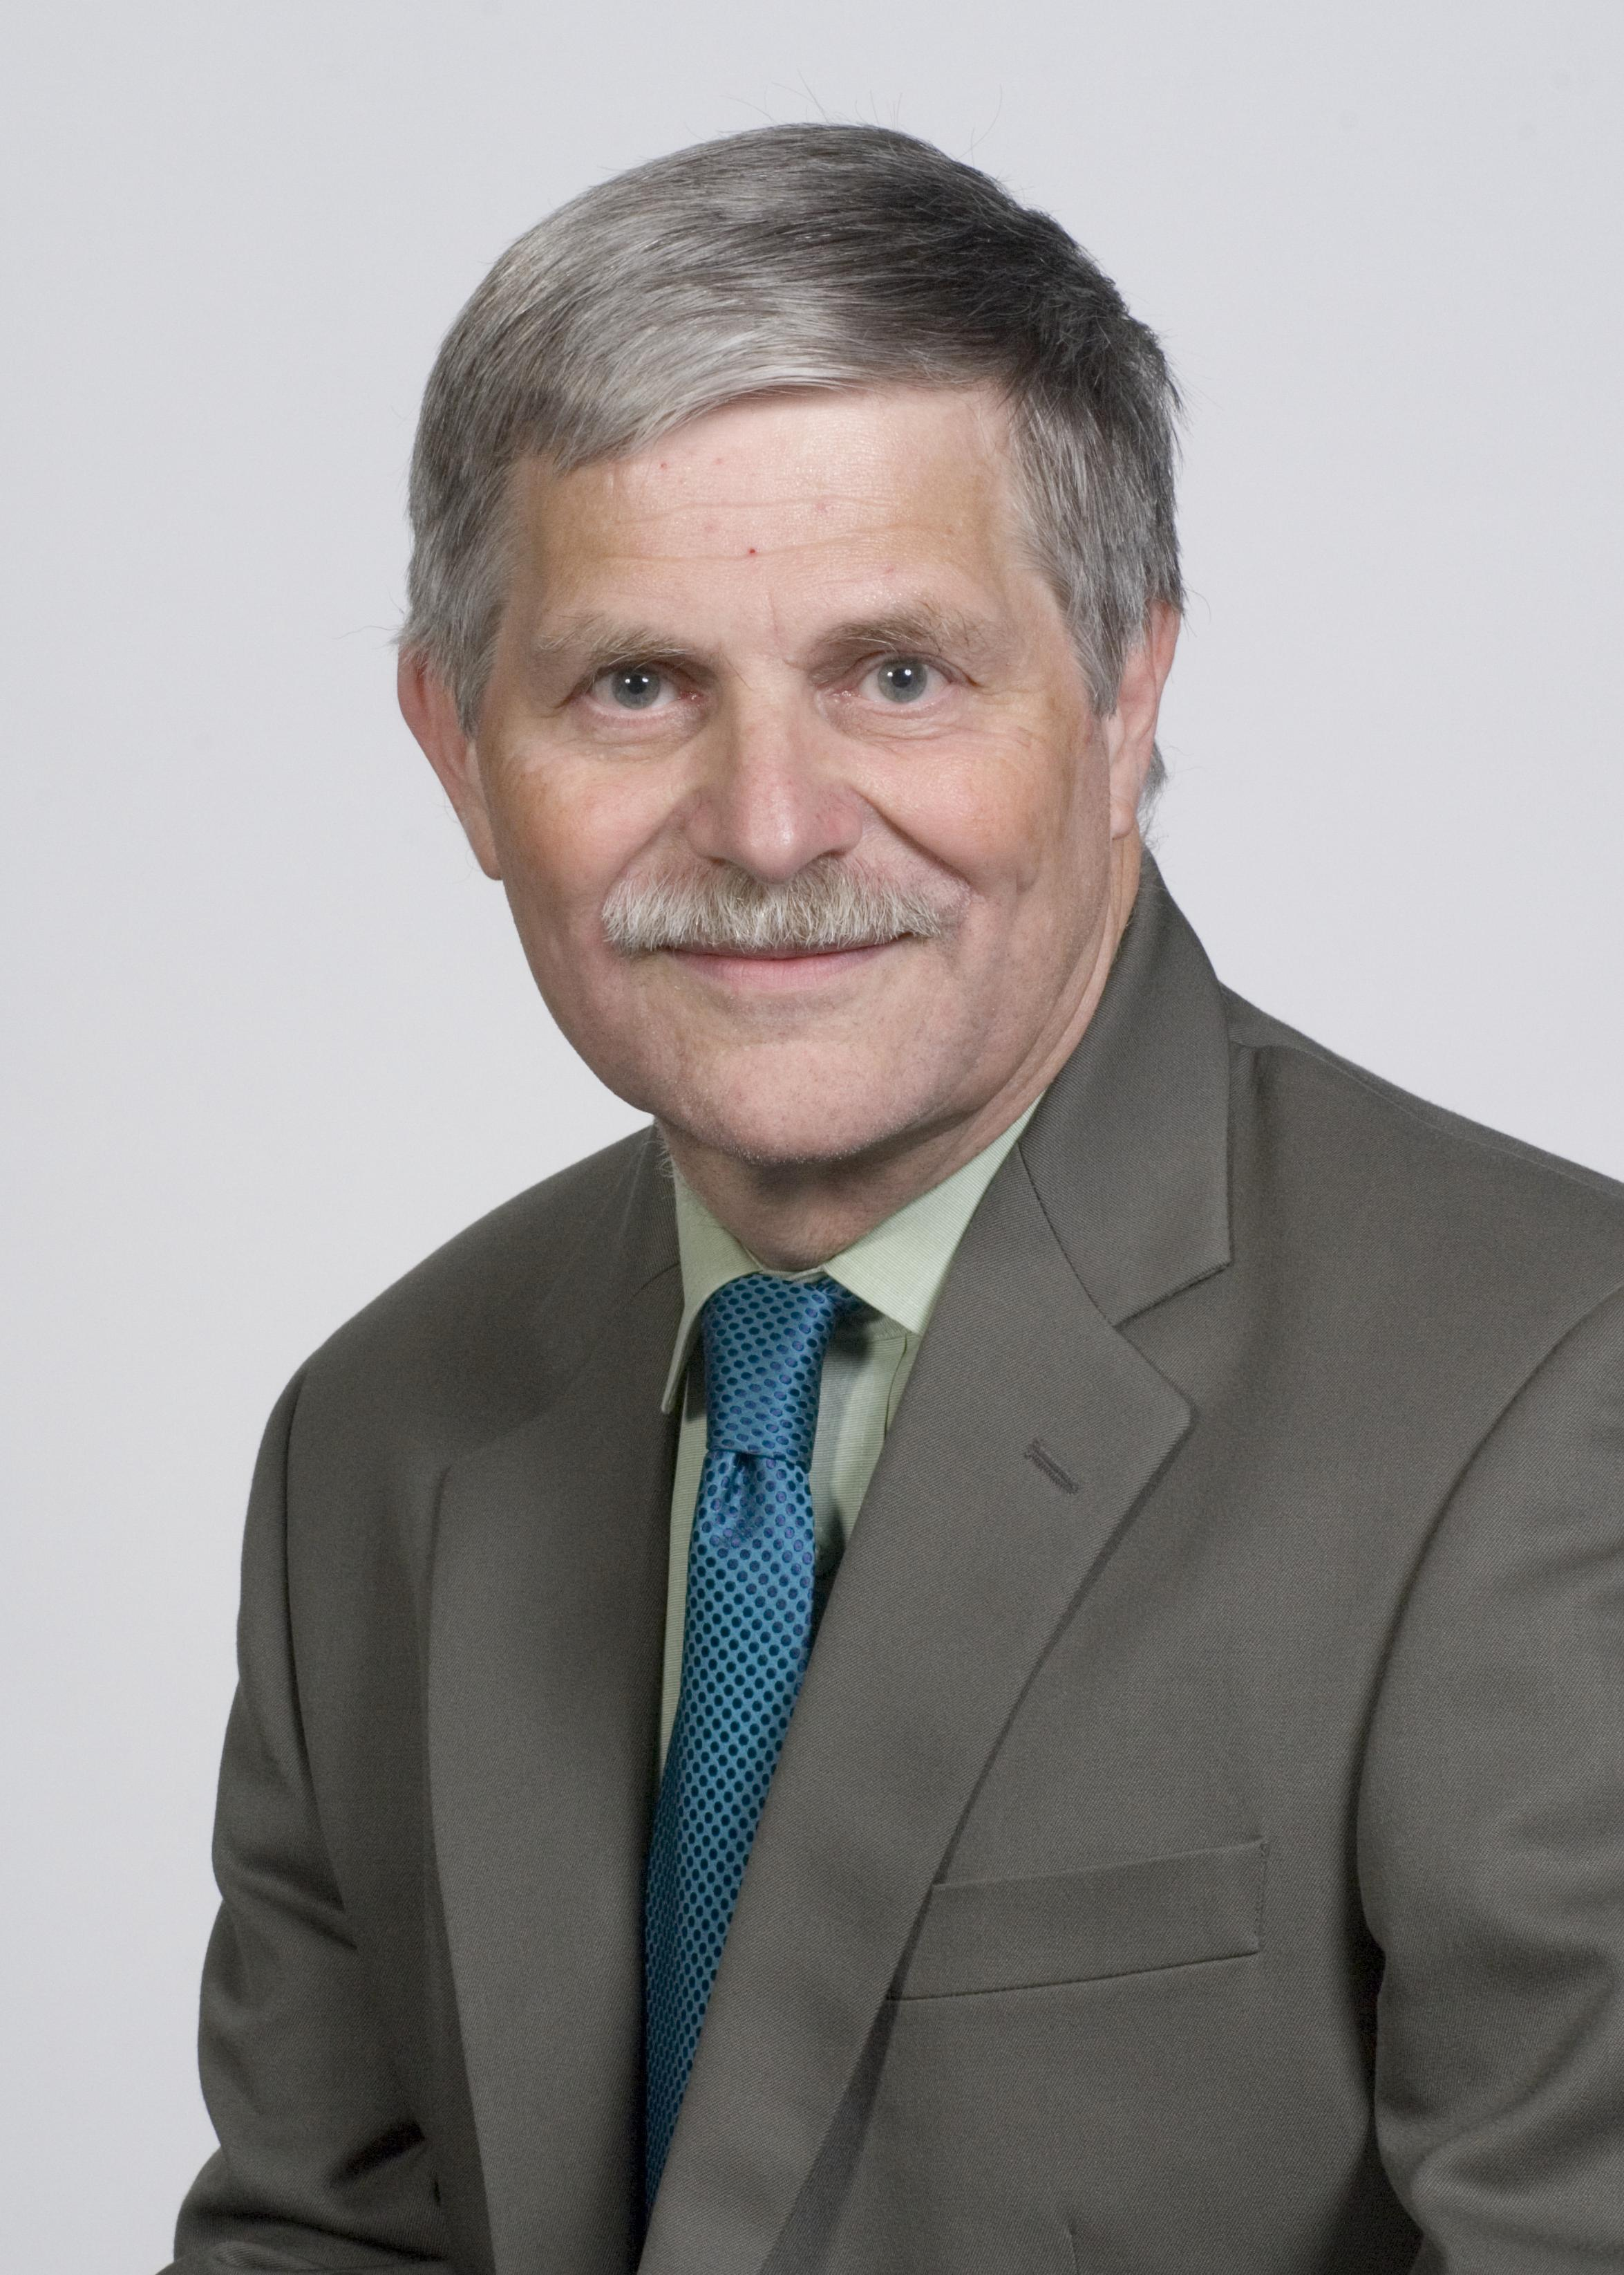
Roy has a BA in philosophy from the University of Toronto and a Masters in Public Administration from York University. He is currently Executive Director and was a founding member of MISA/ASIM Canada. He is a Board Member and Past President of the Institute for Citizen Centred Service, Past President of MISA Ontario, former municipal Co-Chair of the Service Mapping Subcommittee and Project Director for the Municipal Reference Model (MRMv2) project. In the past, Roy was a municipal representative on the Public Sector CIO Council, municipal Co-Chair of the Lac Carling Conference on Electronic Government, member of the Board for Regional Networks for Ontario, and Past Chair of the Showcase Ontario Awards Panel. Roy is a regular contributor of articles to MISA Municipal Interface.

In 2007, Roy became the first municipal recipient of the Heintzman Leadership Award, which recognizes outstanding leadership within the Canadian public sector in promoting citizen-centred service. In 2008, he received the Peter Bennett Award for his outstanding contribution to the Canadian municipal IT community.

